

**YEAR: 12**

**GENERAL BIOLOGY**

**Please do not mark this paper.**

MULTIPLE CHOICE (15 marks)

1. The key event in the life cycle of an organism that relates to the survival of the species is:
2. a) birth.
3. b) fertilisation.
4. c) growth.

d) reproduction.

|  |  |
| --- | --- |
| 1. Vegetative reproduction is: | |
|  |

1. asexual reproduction in plants.
2. b) biodiversity of plants
3. c) selective breeding of plants.

d) sexual reproduction in plants.

|  |  |
| --- | --- |
| 1. Whi3. Which one of the following is not a form of asexual reproduction? | |
| 1. a) Binary fission |
| 1. b) Fertilisation |
| 1. c) Parthenogenesis |
| 1. d) Fragmentation |

1. Mitosis is the division of a cell's nucleus into two daughter nuclei. Which of the following statements about mitosis is correct?
2. The two daughter nuclei each carry half as many chromosomes as the

original nucleus.

1. The DNA in each of the daughter nuclei is an identical copy of the DNA in the original nucleus.
2. Each daughter nucleus carries twice as much DNA as the original nucleus.
3. The two daughter nuclei each have twice as many chromosomes as the original nucleus.
4. Which of the following statements about cell division is most correct?
5. Mitosis occurs during asexual reproduction.
6. Meiosis begins immediately after fertilisation.
7. Mitosis explains why three brothers do not look alike.
8. Meiosis involves the mutation of chromosomes.

6. Hermaphrodites are individuals who:

1. a) produce both male and female sex cells.
2. b) reproduce asexually.
3. c) produce sex cells that can fertilise other sex cells.
4. d) have male or female sex organs.

7. Which one of the following reproduces using spores?

1. Frog
2. Fern
3. Hydra
4. Flowering plant
5. The following diagram shows a species of flowering plant called a kangaroo paw. It produces a large amount of nectar near the ovary.

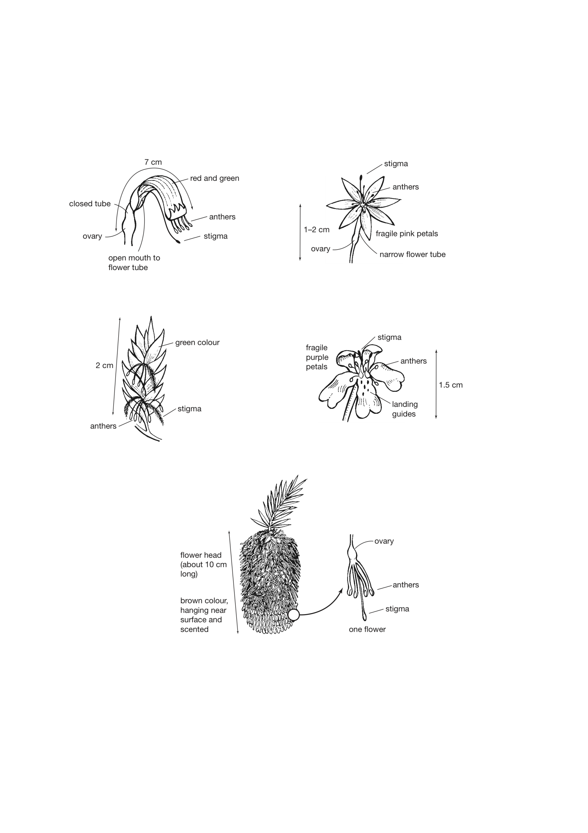

Which of the following predictions is supported by the structure of this flower? The flower is:

a) wind pollinated because the anthers are large and the flower is brightly coloured

b) self pollinated because it has the anthers and stigma close together

c) cross pollinated by insects because the flower is large enough to provide lots of food

d) bird pollinated because the anthers and stigma are a long way from the nectar source

1. Which of the following statements is correct?
2. Ovulation refers to the release of egg cells from the uterus.
3. Fertilisation refers to the production of female gametes.
4. Menstruation refers to the shedding of the lining of the ovaries.
5. Gestation refers to the time between fertilisation and birth.
6. Comparing their roles in reproduction, which of the following in humans is most like the seed in a flowering plant?

a) egg

b) ovary

c) embryo

d) sperm

Information for Question 11 and 12

An experiment on germination was set up as shown in the diagram below.

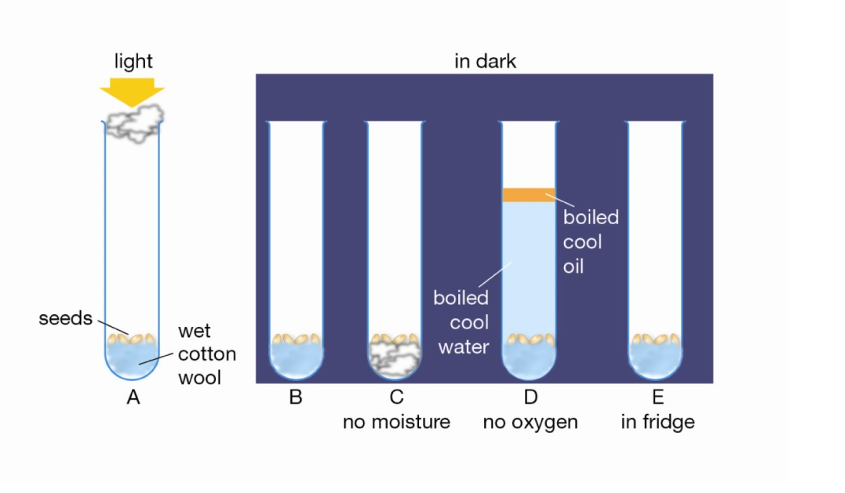

11. To deduce the effect of oxygen on germination, the two tubes that must be compared are:

a) B and C

b) A and D

c) D and E

d) B and D

12. Which test tube acts as a control for test tube E when deducing the effect of temperature on germination?

a) Tube A

b) Tube B

c) Tube C

d) Tube D

13. Aphids have separate male and female individuals. Aphids often reproduce by parthenogenesis, during which females produce eggs that turn into young aphids. However, this is an example of asexual reproduction. The explanation for this classification must be that:

a) asexual reproduction involves making eggs.

b) male aphids do not produce sperm.

c) the eggs were never fertilised.

d) aphids do not reproduce sexually.

14. From the following list predict which would show the greatest differences amongst themselves.

a) aphids produced by parthenogenesis from one parent

b) potato plants grown from one parent plant

c) seedlings from the seeds of one flower

d) moss plants grown from one spore case

15. Organisms that employ external fertilisation are more likely to produce large numbers of eggs and sperm. This is becauseTop of Form

1. large numbers of eggs and sperm are more likely to fertilise than smaller numbers.
2. externally fertilised eggs are usually those of organisms that are tiny and are found in large numbers.
3. externally fertilised eggs are not protected from predators or the environment.
4. it is easier for parents to protect a larger number of developing offspring.

**Year 12**

**General Biology**

|  |
| --- |
| Name: |
| Teacher: |

|  |  |  |  |
| --- | --- | --- | --- |
| **Task 2: Test** | | | Weighting 7.5% |
| Marks Received | Marks Available | Percentage | |
|  | 63 |  | |

Time Allocated:

Working time: 60 minutes

**Multiple Choice Short Answer Extended Answer Total**

**/40**

**/15**

**/8**

**/63**



**TEST: Reproduction**

**ANSWER BOOKLET**

**NAME:**

**FORM:** **DATE:**

**SECTION ONE:** Multiple choice answers

Cross (X) through the correct answer.

|  |  |  |  |  |  |  |  |  |  |  |
| --- | --- | --- | --- | --- | --- | --- | --- | --- | --- | --- |
| **1** | a | b | c | d |  | **11** | a | b | c | d |
| **2** | a | b | c | d |  | **12** | a | b | c | d |
| **3** | a | b | c | d |  | **13** | a | b | c | d |
| **4** | a | b | c | d |  | **14** | a | b | c | d |
| **5** | a | b | c | d |  | **15** | a | b | c | d |
| **6** | a | b | c | d |  | **16** | a | b | c | d |
| **7** | a | b | c | d |  | **17** | a | b | c | d |
| **8** | a | b | c | d |  | **18** | a | b | c | d |
| **9** | a | b | c | d |  | **19** | a | b | c | d |
| **10** | a | b | c | d |  | **20** | a | b | c | d |

**Short Answer Section ( 40 marks)**

**16)**

a) Label the two circles of the Venn diagram below indicating the **two main types of**

**reproduction**. (2 marks)

b) In the middle or overlapping section, list two **similarities** between the two types of reproduction. (2 marks)

c) In the left and right sides, list three **differences** between the two types of reproduction. (6 marks)

17) Label the diagram of the dissected flower below to identify both the male and female reproductive parts. (4 marks)

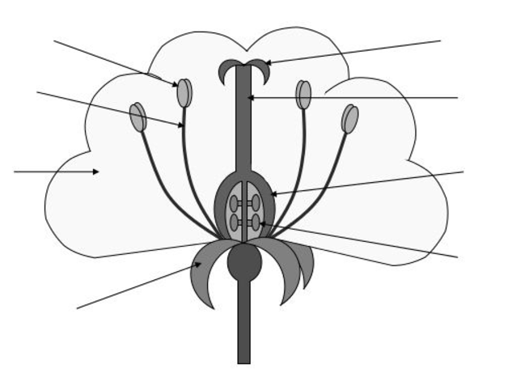

**18.** Complete the following table by describing 2 types of **asexual reproduction**: (6 marks)

|  |  |  |
| --- | --- | --- |
| **Type of asexual reproduction** | **Explanation of how it works** | **Example of an organism that uses this type** |
|  |  |  |
|  |  |  |

19**.**  Complete the following table using the choices in each column. (6 marks)

|  |  |  |  |  |
| --- | --- | --- | --- | --- |
|  | Fertilisation  (external/internal) | Development  (eggs/ live young) | Number of offspring (few/many) | Parental care  (none/some/ extensive) |
| Fish |  |  |  |  |
| Reptiles |  |  |  |  |
| Mammals |  |  |  |  |

20. Flowering plants may either be self-fertilised or cross-fertilised. (3 marks)

A **Describe** one feature of plants that ensures cross-fertilisation will occur.

B **Clarify** the advantage of cross-fertilisation.

21. Explain why the human species can survive by a process of reproduction that usually involves only one ‘egg’ each mating, whereas a frog species produces thousands of eggs each time it mates. (3 marks)

22. Discuss the various strategies used by flowering plants to ensure that pollination occurs

(4 marks)

23. Many Australian plants are naturally adapted to the presence of regular bushfires. Describe two methods by which Australian plant populations are able to persist after bushfires. (4 marks)

**EXTENDED ANSWER (8 marks)**

24. Plants and animals can produce new cells through the processes of mitosis and meiosis.

Discuss these processes taking care to:

* + 1. explain the purpose(s) of the type of cell division (2 marks)
    2. describe the differences in the cells that are produced (6 marks)